Git and Github Tutorial notes:

**Git**:

It is a version control system, that helps us keep track changes in

code. It is an open source, fast and scalable application.

**Github:**

A website that allows developers to store their code using git.

First Task at hand:

Create a repository and make our first commit.

By creating our repository and also making sure to include :

‘Readme.md’ file our repository is successfully created and then in

the repository page this appears :

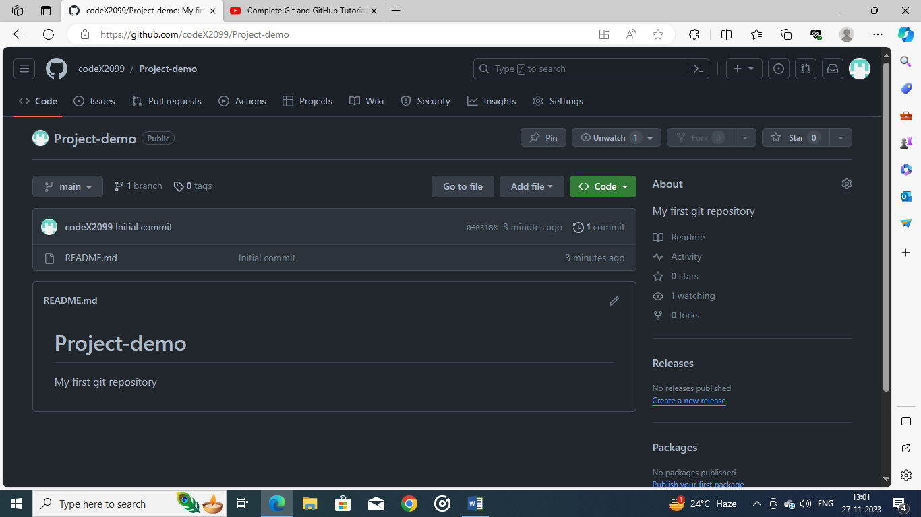

A statement ‘initial commit’ has been created which means; some

change has been seen in the repository. To make changes permane-

ntly is called **‘Commit’,** conversely ‘Add’ means inserting somethi-

ng in the repository and ‘commit’ means to finalize it.

Now suppose we added something to the ‘Readme.MD’ file, we

Then given the box of updating ‘Readme.MD’ upon updating we

get this:

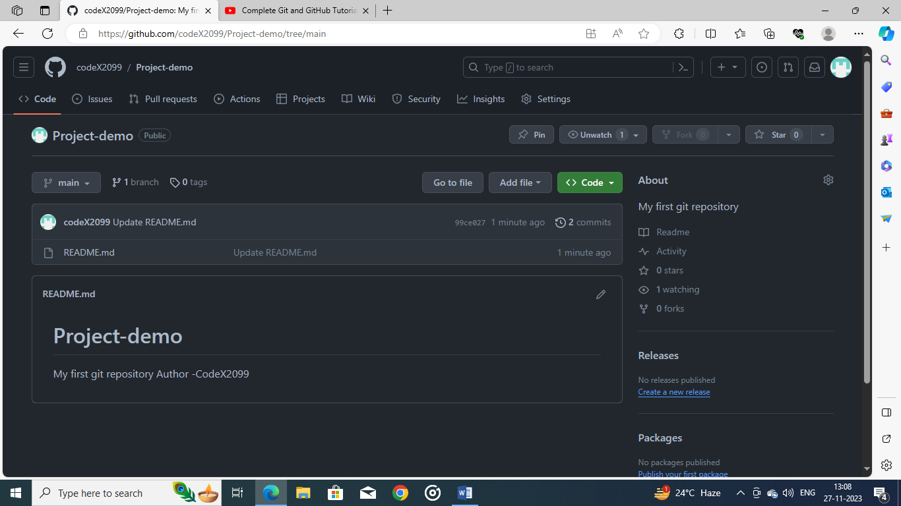

Now we need to install git from the official website and then configure it like this:

git config – global--user.name “My Name”

git config -- global user.email [*****@gmail.com](mailto:*****@gmail.com)

git config – list

By running all these commands, we have setup our git account there.

How to know if we did everything correctly? Through VScode like this:

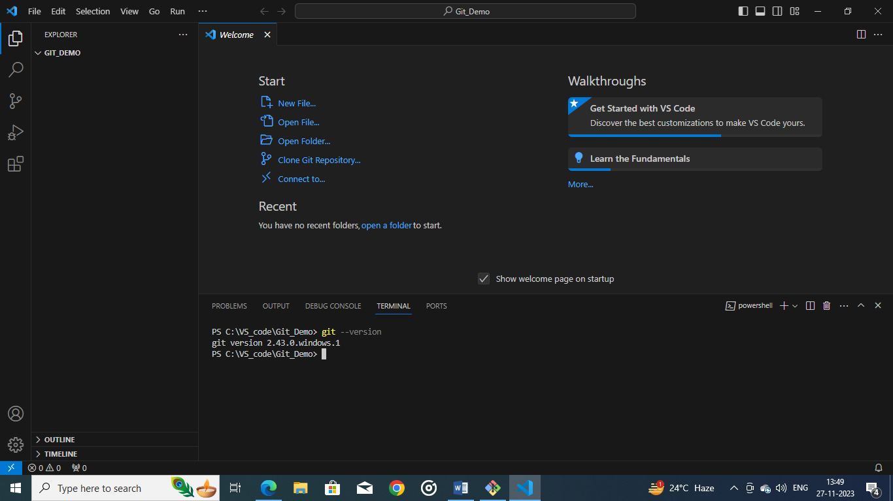

Now we will go through some git commands :

Cloning: clone a repository into your local PC, use the command *‘git clone ‘HTTPS*

*Link’*, following the command it will send and clone all data from the repository and

Will be present in the local computer where you have opened the folder.

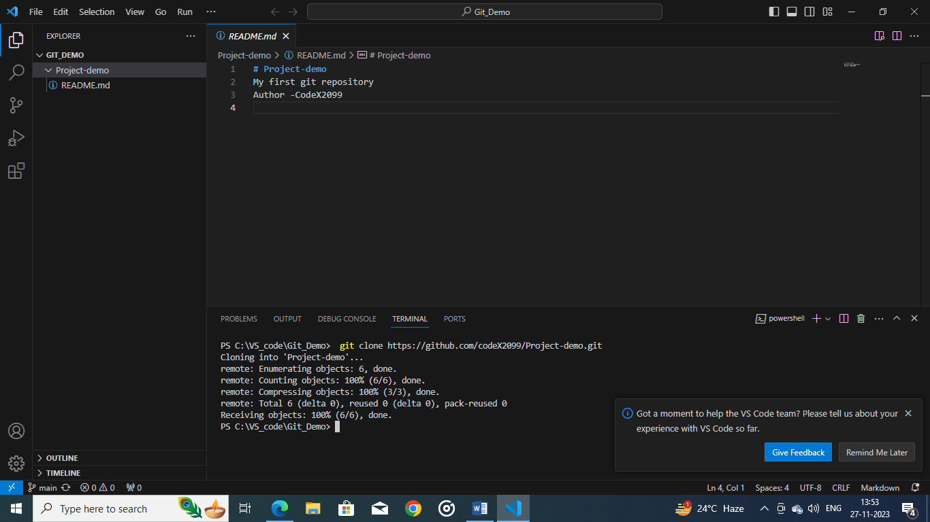

Use command *‘cd’* (change directory) to change to the repository folder, then

*‘ls’* command uses to show all files, then ls –Force shows all hidden files as well.

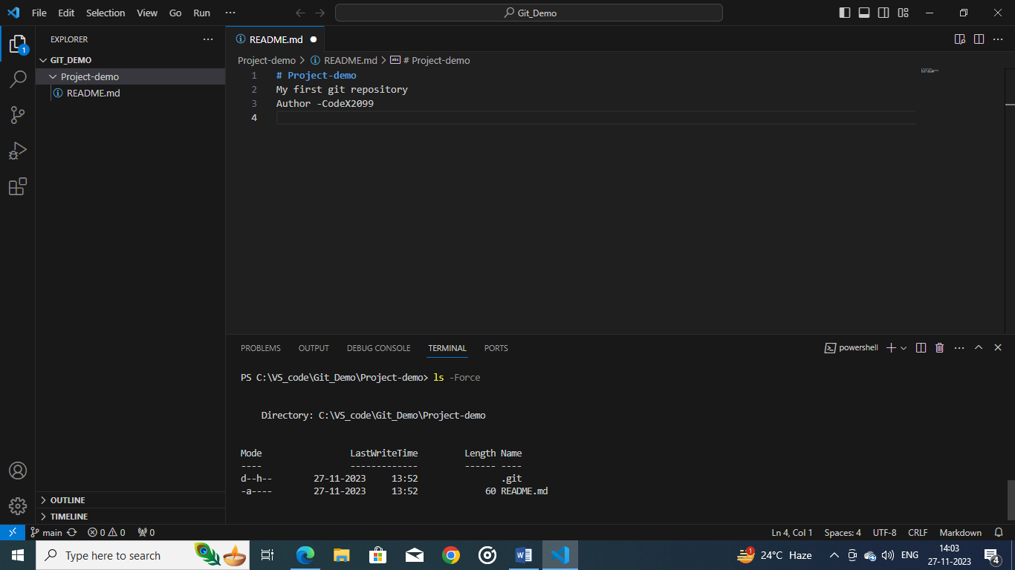

Using *‘git status’* command it shows if any pending commits are to be made, here

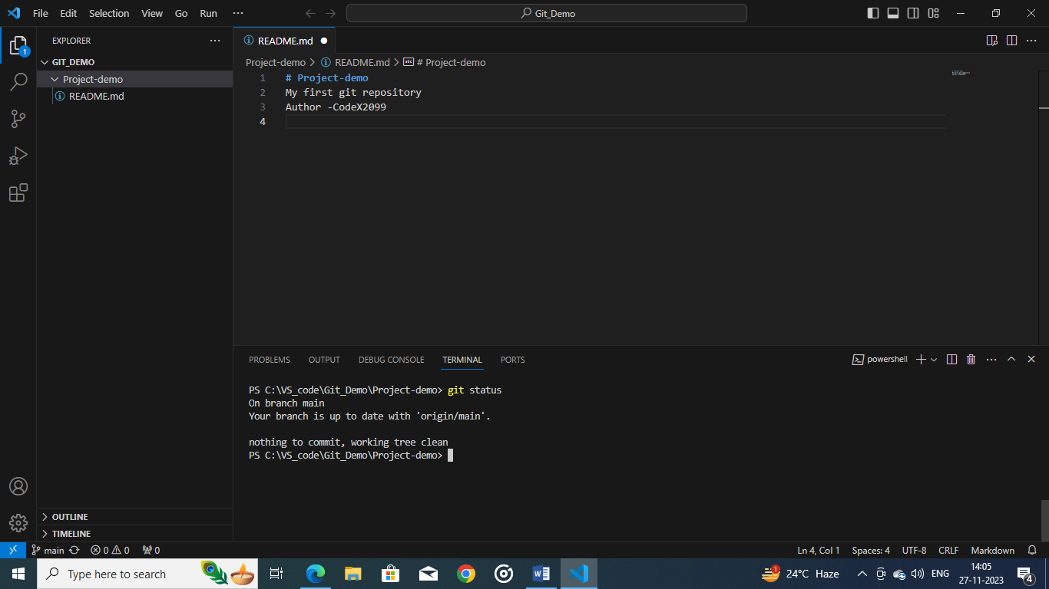

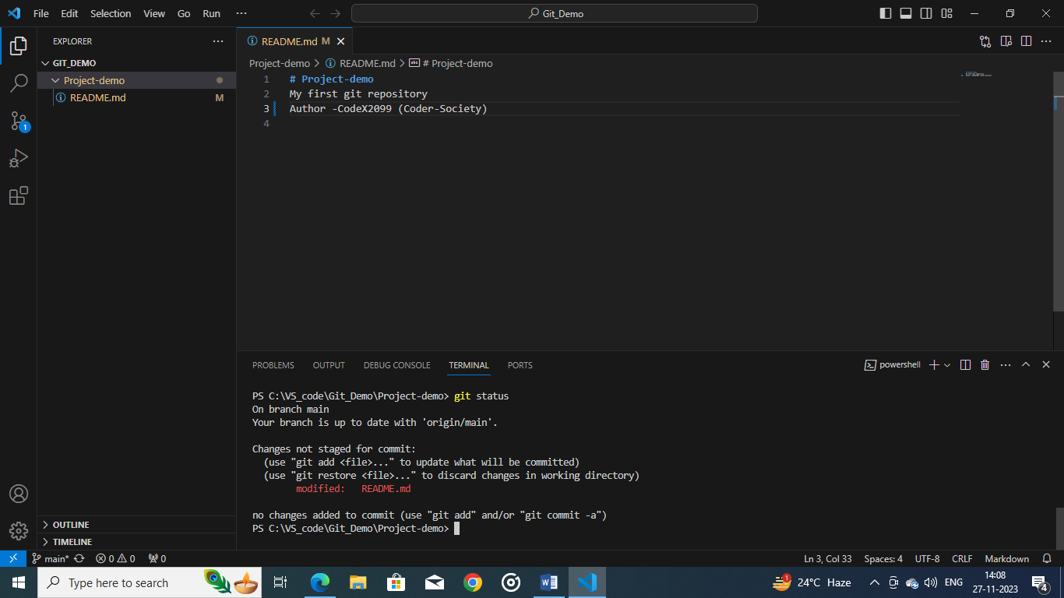

Now here, in the above image we have modified the file a little bit notice, how the VS

Code has been highlighted yellow, indicating that the file is modified, and when we

run the command *‘git status’* then we see that it says changes made has yet to be

committed.

Suppose we create an *‘index.html’* this means we have created an *‘untracked file’*

which means something new has been created

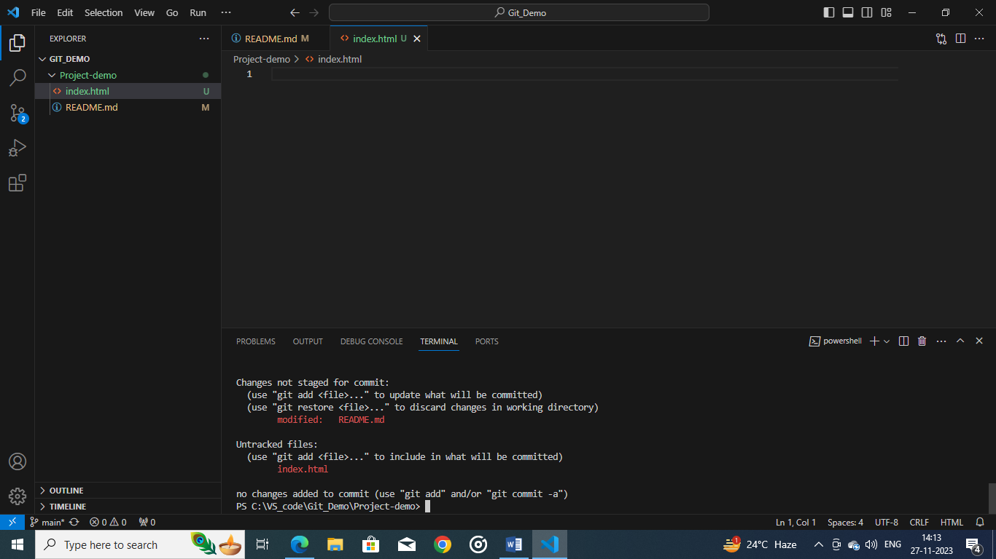

The above picture says it all:

By using *‘git add .’* adds all modified changes and any new files to the repository.

Then we use ‘git commit –m *“your message”* which finalizes the changes and brings

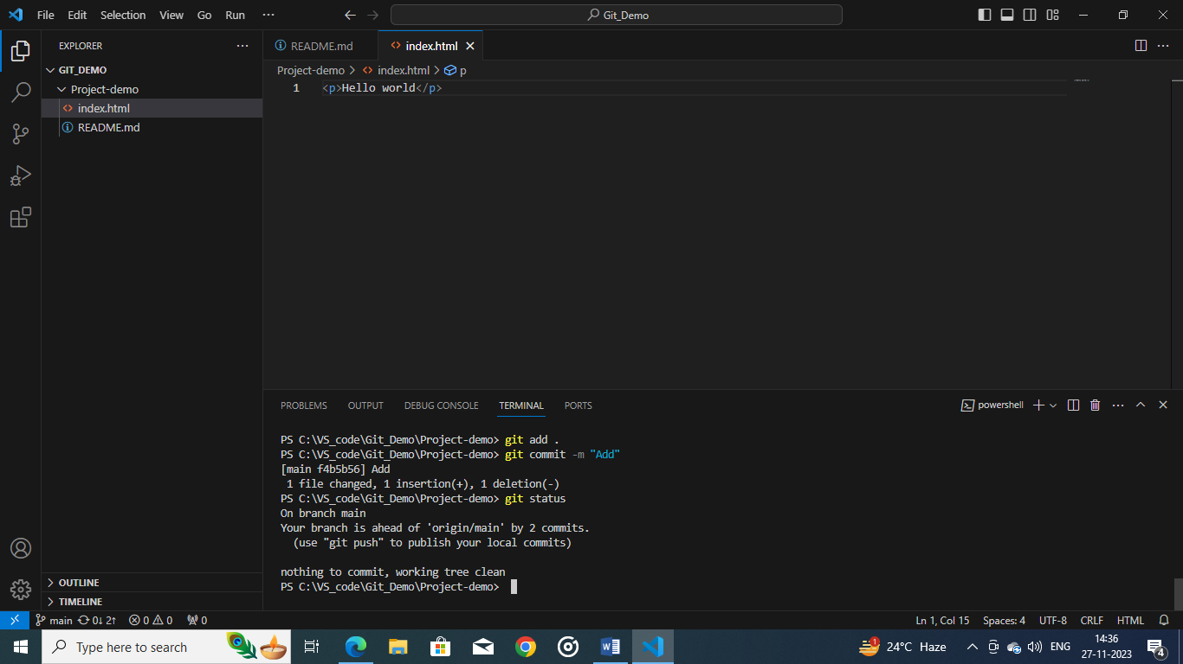the output.

But there is one problem, this is seen in our computer but not github website:

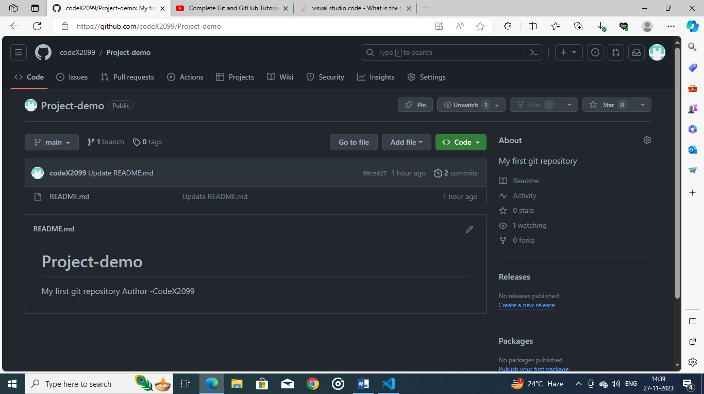the changes are not visible there

We use a new command *‘git push origin main’* ; which means upload local data to

remote repository and then the changes appear like this:

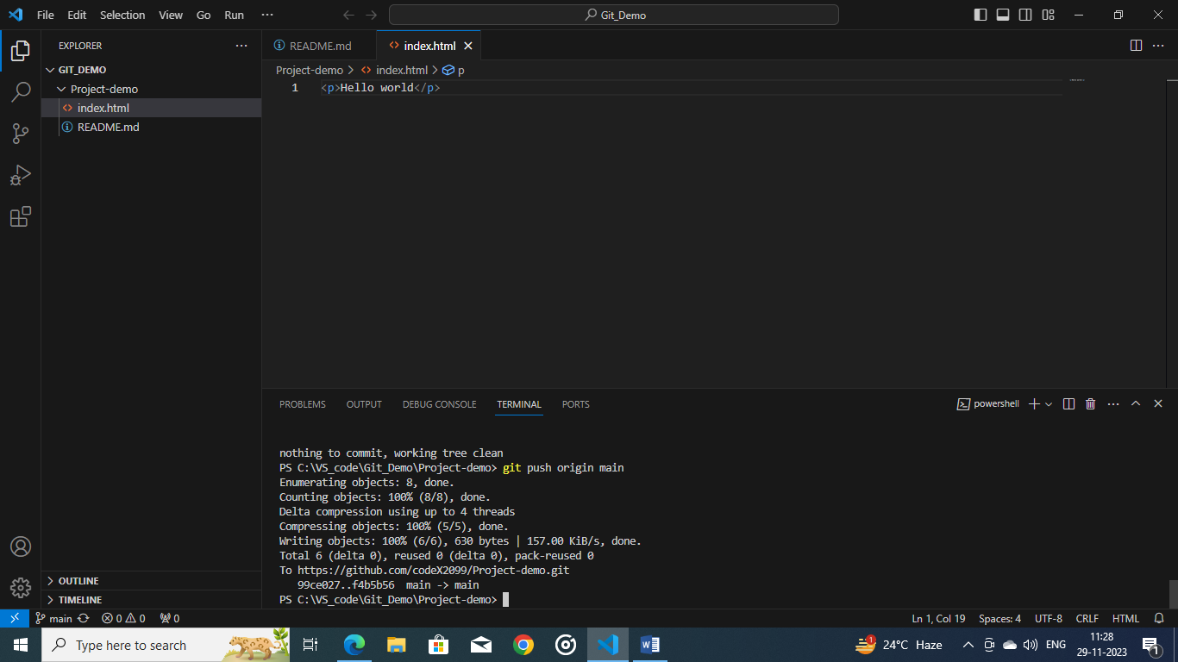

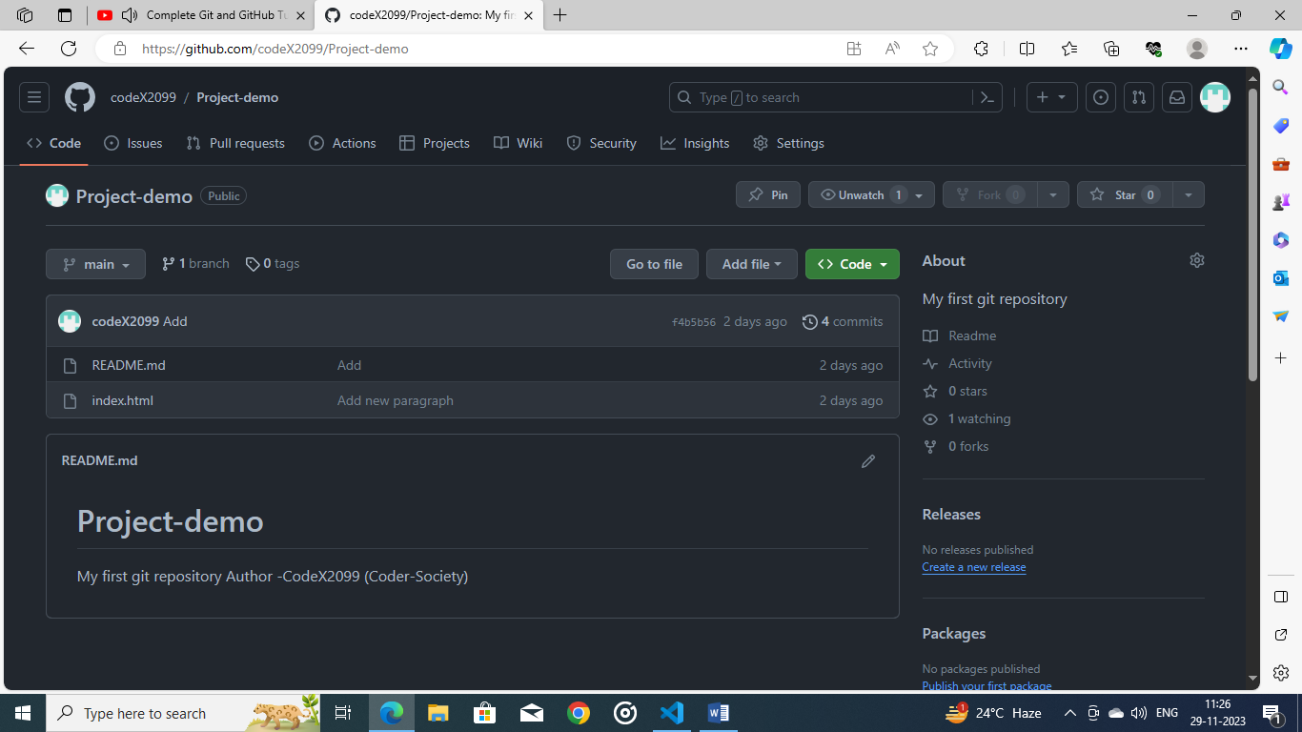

Also the changes should be visible to the screen their…..sometimes if you do it the

first time you might need to grant access, otherwise since git has already registered

your email id and username, a popup may not appear. The changes made will then be

visible, do refresh the github page.

Now we will learn more about git branches.

Supposedly we want to make a new repositroy for our project we will first exit the

current repository: by the command *‘cd ..’* and then type the command; *‘mkdir’* which

stands for ‘make_directory’

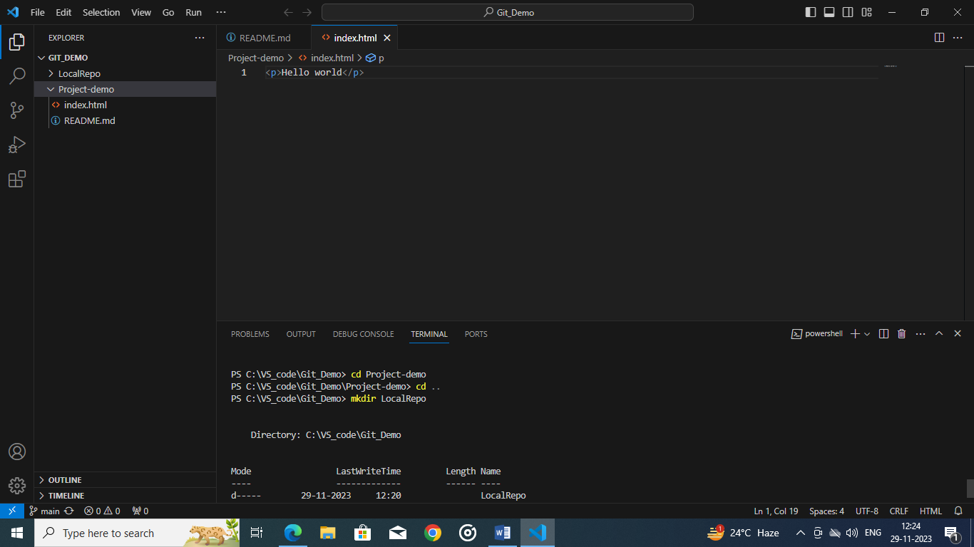

Because we created *‘LocalRepo’* it is not a git repository…..an empty container, but

initializing with *’git init’* we then create an empty repository like this :

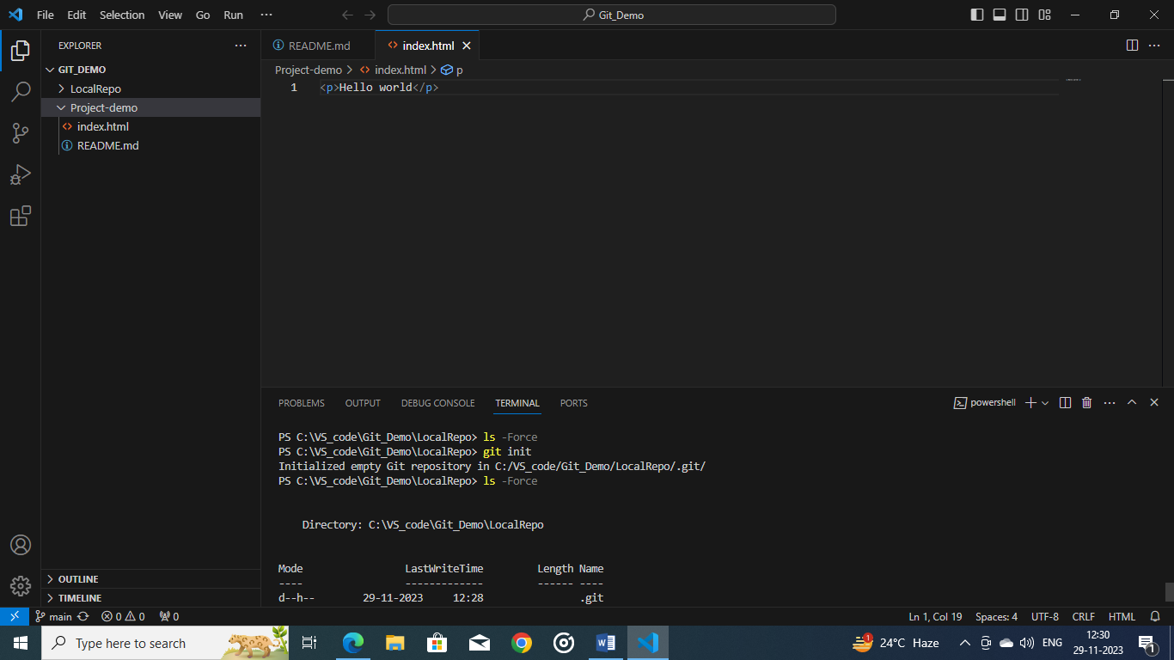

We now add any types of file to the new repositry with the same steps: This is before

Adding the files to the repository and then after using *‘git add .’*

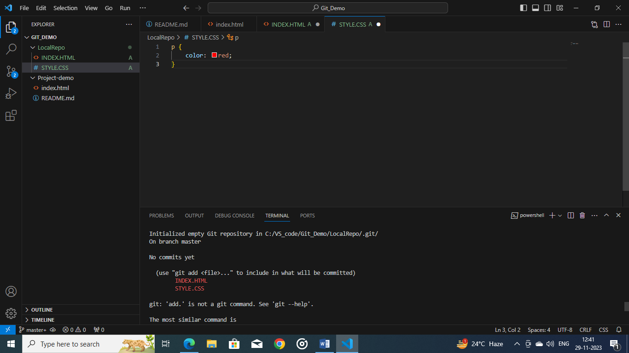

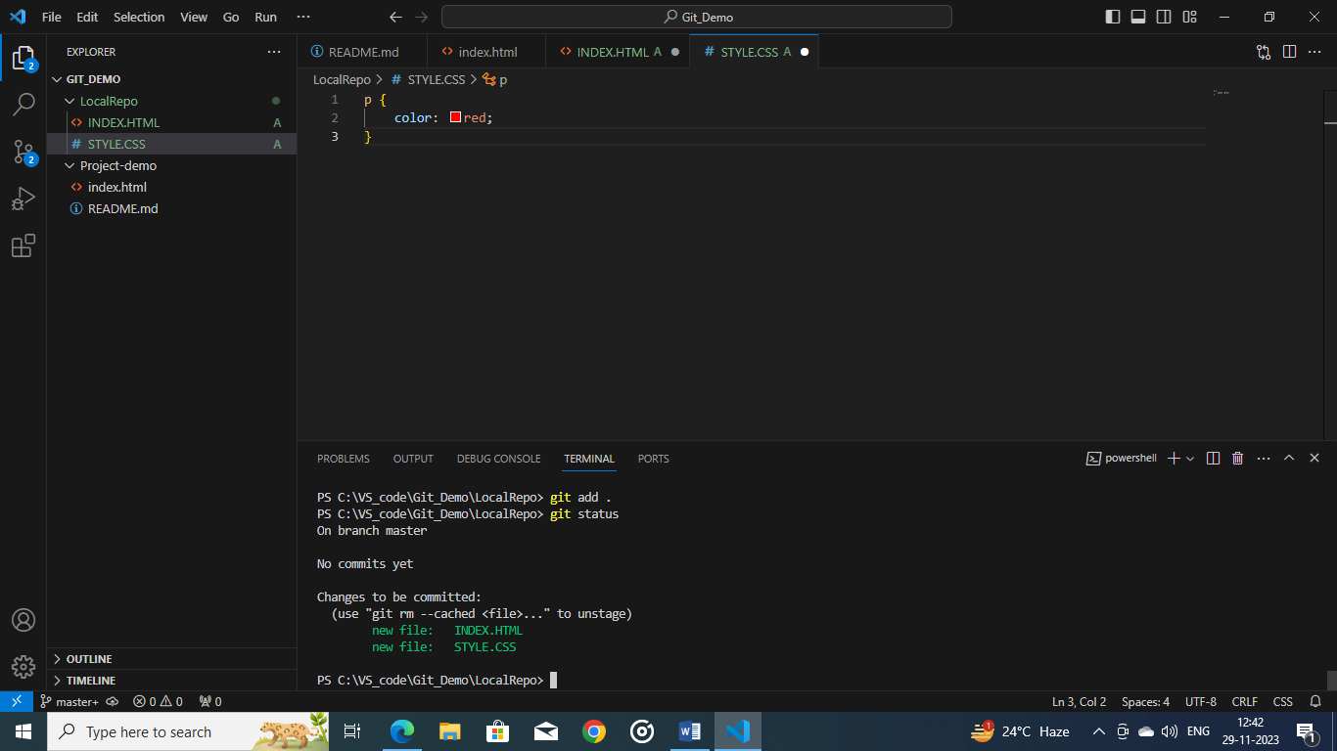This is change the will happen:

Now that we have added the files to another LocalRepo to the Local Data then,

Add the files to the local repo and should attain a result like this:

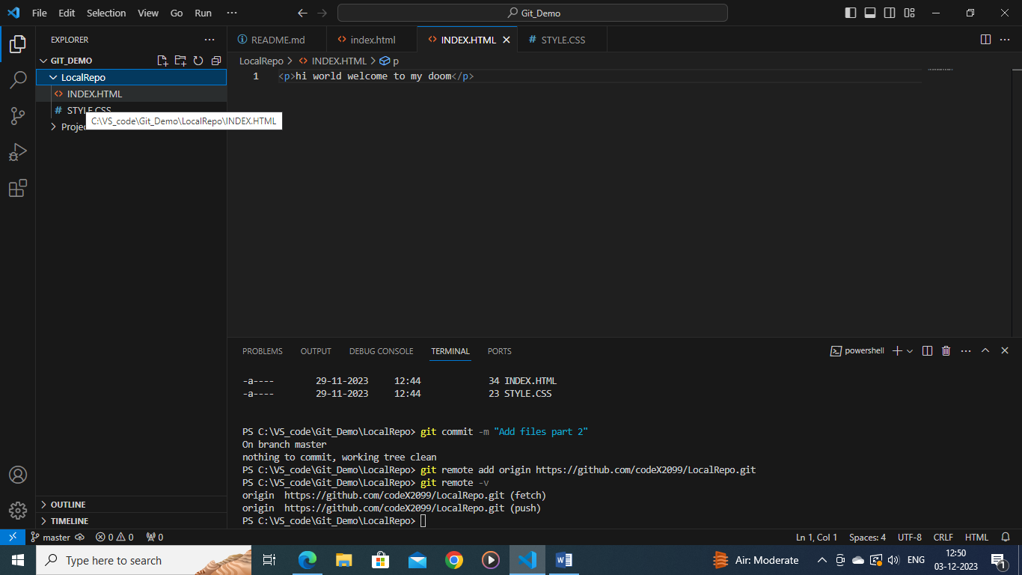

Now we have the topic of ‘*git branch*’; so this is a resemlance of a Tree like structure

In real life where the main part of the tree is the trunk (master) : meaning the trunk

(master) is the main part of your storage and the ‘branches’ are separate spaces

to store files but they wont be added to the ‘Master’ node.

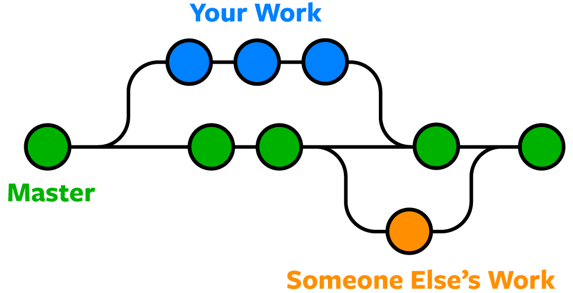

The ‘*Master*’ is the main hub of storage while the branches are your and other people

‘s separate work.

Now we need to push the files in the local repo to the github website; and also we will

learn a new shortcut name ‘*git push –u origin main’* which means if we want to push

keep pushing our files to the same repository we just say ‘git push –u’ u signifies

‘origin main’ which is like a shortcut code.

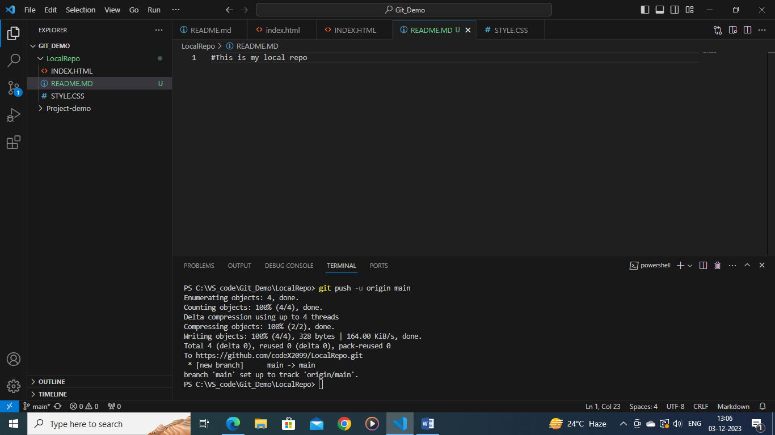

Here we have a readme file where we are adding some text to this. So now we add

the file to the local repo ‘*git add .’* command using that then through status checking

and then, we commit the file with the msg “Adding the readme file”; finally push to

the github website.

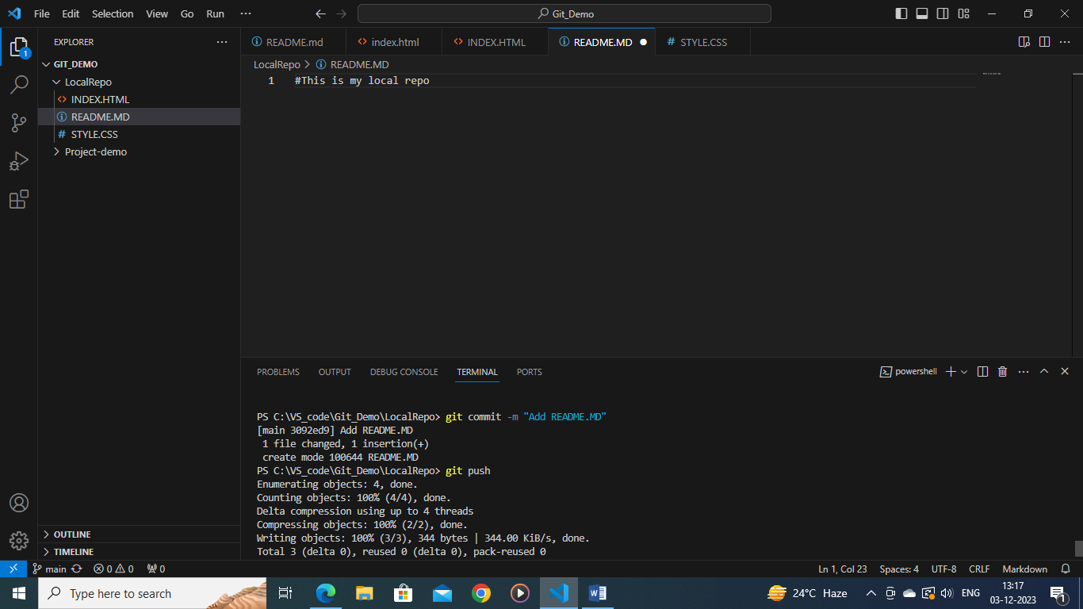

So, the change will appear after refreshing. The change before pushing is this:

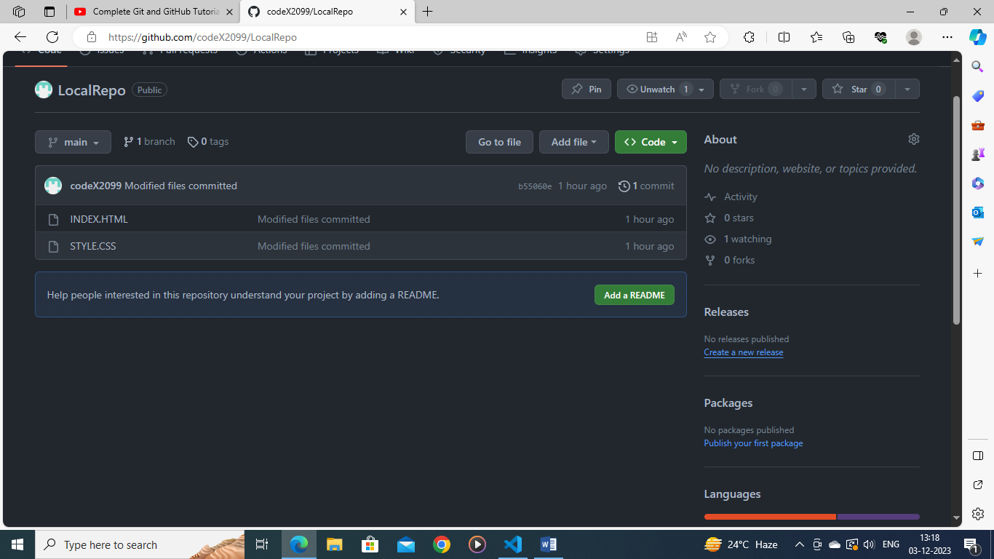

After refreshing the page this should appear here:

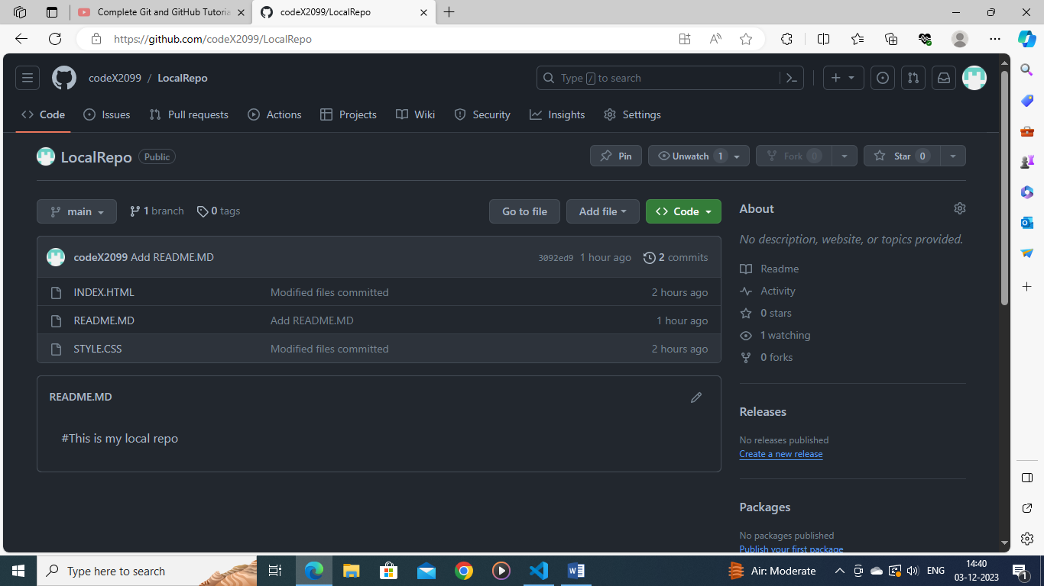

For more information: use the video reference for more information about Git and

Github. ([Complete Git and GitHub Tutorial for Beginners - YouTube](https://www.youtube.com/watch?v=Ez8F0nW6S-w&t=2198s))

Reference of Git and Github master node :

<https://blog.whooshpro.com/articles/what-is-github-a-beginners-introduction-to> git-and-github/